To: Professor Martinez

From: Murtaza Amjad

Date: 3/20/2024

Subject: Lab 3 Technical Memo

The lab goal was to add the ability for the Arduino UNO R3 to be able to save the commands it was given even after it was taken out and plugged back into the USB port. The parts used in the lab were the Arduino UNO R3, 3-color RGB light, reed switch, button, wires, USB power cable. These were the same materials used in the previous lab, nothing new with the actual hardware. This lab was more of an upgrade to the software(code) of the Arduino. If I started off with the id 00780749 and changed it to 09090909. Even after I plugged out the Arduino the id will remain 09090909 because of the EEPROM code implementations made. This also goes for the color of the dash, dot, and the speed of the lights. To use EEPROM I had to include the header file “#include <EEPROM.h>”.

Some of the problems I ran into was getting the Arduino to save the id number, colors, and speed. For some reason when the id is preset it makes it hard for the code to run properly and save the new code. But when I leave it blank for the user to input an id in then it saves it. If you overwrite that id with a new id, then it will start using the new id only. I had to change my code from “int myID[] = {0,0,7,8,0,7,4,9};” to “int myID[8];” for the Arduino to save the id. For the color of the dash and dot I did not need to uninitialize it because it worked and stayed the same even if the preset was for the dash to be red. If I changed it to green, then it will stay green. Either “int colorofDash = redLed;” or “int colorofDash;” works.

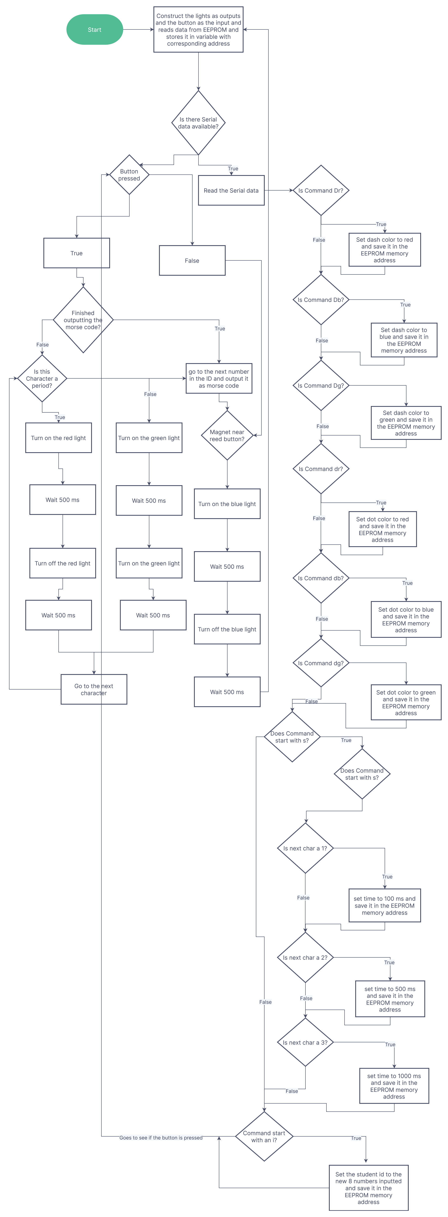

Figure 1. Program Flowchart

The flowchart quickly shows you how the program runs and what happens at each step of the way. If you follow the chart, you can see it describes what is happening in the demonstration. It helps give a step-by-step process on what's happening when certain things go into effect.

The result of the lab was a successful program that built on top of the last lab. This lab successfully implemented the saving system for the Arduino. Allowing it to save any changes made to the color of the dash, color of the dot, speed of the lights, and the id #. After making the changes the EEPROM.write() saved the changes to the Arduino so when unplugged and plugged back in the changes were saved. This is the communication between the software and the hardware of the Arduino. The software was able to keep track of the changes made and output those changes to the hardware.

Appendix:

Sources-

Morse Code Link - <https://www.sckans.edu/~sireland/radio/code.html>

Code:

#include <EEPROM.h>

int greenLed = 5;

int blueLed = 7;

int redLed = 6;

int reedbutton = 10;

int startbutton = 4;

int myID[8];

int idx = 0;

int time;

int press;

const char* morseID[10] = {"-----",".----","..---","...--","....-",".....","-....","--...","---..","----."};

int colorofDot;

int colorofDash;

int speedofLights;

String input;

String newID;

void setup() {

// put your setup code here, to run once:

pinMode(redLed,OUTPUT);

pinMode(greenLed,OUTPUT);

pinMode(blueLed,OUTPUT);

pinMode(startbutton,INPUT_PULLUP);

pinMode(reedbutton,INPUT_PULLUP);

Serial.begin(9600);

for (int x = 0; x < 8; x++){

myID[x] = EEPROM.read(x);

}

time = EEPROM.read(9);

colorofDot = EEPROM.read(10);

colorofDash = EEPROM.read(11);

}

void loop() {

// put your main code here, to run repeatedly:

if (Serial.available() > 0){

input = Serial.readString();

Serial.println(input);

if (input.startsWith("dr")){

colorofDot = redLed;

EEPROM.write(10,redLed);

}

else if (input.startsWith("db")){

colorofDot = blueLed;

EEPROM.write(10,blueLed);

}

else if (input.startsWith("dg")){

colorofDot = greenLed;

EEPROM.write(10,greenLed);

}

else if (input.startsWith("Dr")){

colorofDash = redLed;

EEPROM.write(11,redLed);

}

else if (input.startsWith("Db")){

colorofDash = blueLed;

EEPROM.write(11,blueLed);

}

else if (input.startsWith("Dg")){

colorofDash = greenLed;

EEPROM.write(11,greenLed);

}

else if (input.startsWith("s")){

speedofLights = input.substring(1).toInt();

if(speedofLights == 1){

time = 100;

EEPROM.write(9,100);

}

else if (speedofLights == 2){

time = 500;

EEPROM.write(9,500);

}

else if (speedofLights == 3){

time = 1000;

EEPROM.write(9,1000);

}

}

else if (input.startsWith("i")){

newID = input.substring(1);

for(int i = 0; i < 8; i++){

myID[i] = newID[i] - '0';

EEPROM.write(i,myID[i]);

}

Serial.println("The new ID is: ");

for (int i = 0; i < 8; i++){

Serial.println(myID[i]) + '0';

}

}

}

press = digitalRead(startbutton);

if(press == LOW){

for(int i = 0; morseID[myID[idx]][i] != '\0'; i++) {

if(morseID[myID[idx]][i] == '.'){

digitalWrite(colorofDot,HIGH);

delay(time);

digitalWrite(colorofDot,LOW);

delay(time);

}

else{

digitalWrite(colorofDash,HIGH);

delay(time);

digitalWrite(colorofDash,LOW);

delay(time);

}

}

idx++;

if (idx >= sizeof(myID) / sizeof(myID[0])) {

idx = 0;

}

}

//if it the reedbutton is hit then it resets to the first index of the student number

if (digitalRead(reedbutton) == LOW) {

idx = 0;

digitalWrite(blueLed,HIGH);

delay(time);

digitalWrite(blueLed,LOW);

}

}